

*MINI PROJECT*

GROUP MEMBERS:

RAJ MHATRE (2228)

DEVANG SAWANT (2257)

NARENDRA YADAV (2268)

SAIRAJ PAWAR (2245)

PROJECT GUIDE:

**CALCULATOR USING PYTHON**

On this calculator we can perform following simple mathematical calculations –

* Multiplication
* Addition
* Subtraction
* Division

**Creating Window For Calculator**

First of all we will create a window of calculator.

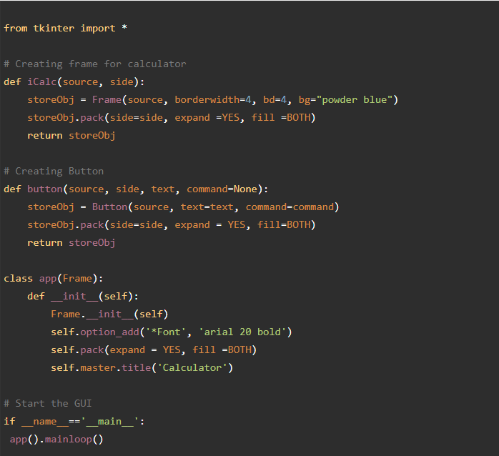

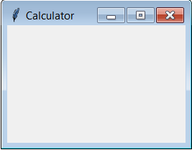

OUTPUT:

created frame successfully

**Adding Display Widget**

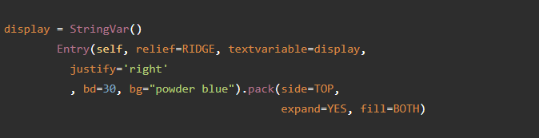

OUTPUT:

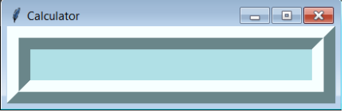

**Adding Clear Button Widget**

create a clear button So Whenever this button will be pressed all the stuffs from display will be erased.

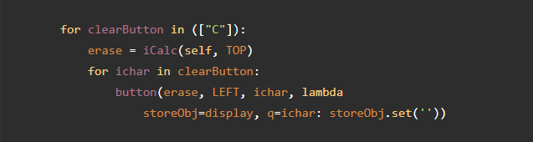

Output:

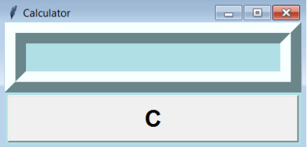

**Adding Numbers And Symbols Widget**

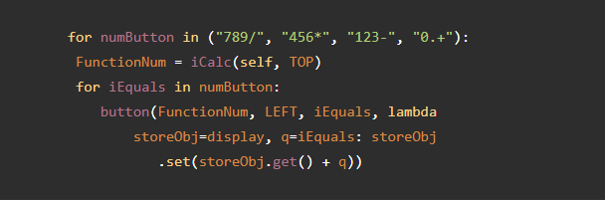

OUTPUT:

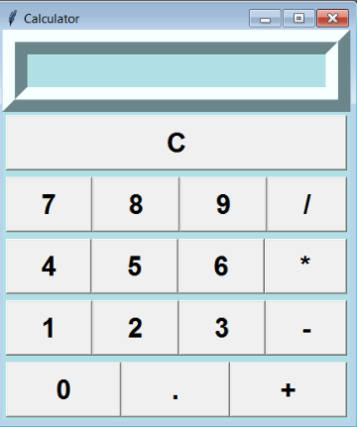

**Adding Equal Button**

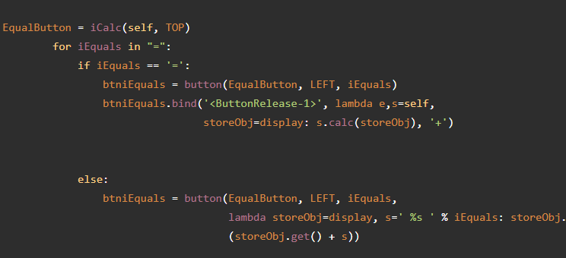

**OUTPUT:**

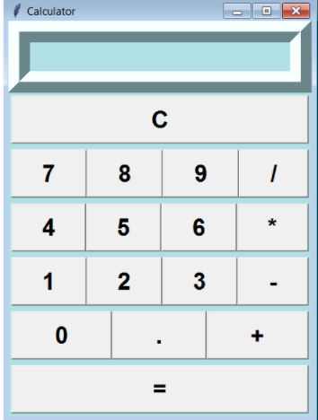

**Applying Event Trigger On Widgets**

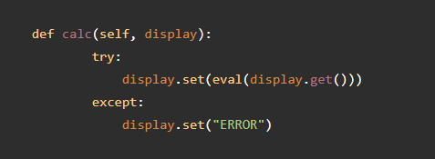

 created python calculator successfully

OUTPUT:

Multiplying 25*25

